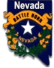
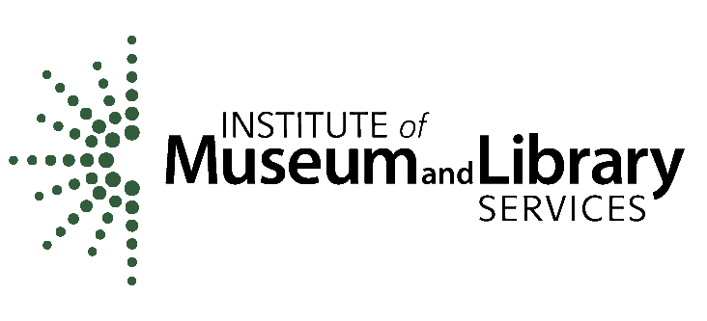
NEVADA STATE LIBRARY, ARCHIVES and PUBLIC RECORDS

Nevada Department of Administration
100 North Stewart Street
Carson City, NV 89701

Federal 2024 LSTA GRANT-IN-AID AWARD

Sub-Grantee: Washoe County Library System

Address: 301 South Center Street, Reno, NV 89501

UEI: GPR1NY74XPQ5

Project Title: Washoe County Library Virtual Conference Centers

Grant Number: 2024-12 P/P# or CFDA #: 45310-24

Sub-Award Project Dates: September 1, 2024-September 30, 2025

General
- Grant funded activities shall provide services and equipment as outlined in the approved grant application. Grant funds must be used to meet NSLAPR Five Year Plan and federal LSTA goals. The approved grant application submitted by the sub-grantee becomes part of this agreement.
- The sub-grantee may not obligate or encumber grant funds prior the effective date of this agreement. Funds may not be obligated or encumbered after September 30, 2025.
- All unexpended grant funds must be returned to the Nevada State Library, Archives and Public Records

Grant Amounts and Reimbursement Procedures
- Total Amount of Federal funds obligated for this project: $66,120
- The sub-grantee must request payments as reimbursement of actual funds expended for the normal grant cycle. Advance payments may be requested under special circumstances and must be authorized by the LSTA Coordinator and NSLAPR Administrator prior to a payment request.
- The sub-grantee may not obligate or encumber grant funds before the effective date of this agreement or after September 30, 2025. Final reimbursement requests must be submitted by October 17, 2025.
- Funds for the grant project are authorized according to the final application budget; required match is at least 10%.

Request for Fiscal and/or Programmatic Changes
The sub-grantee may request a budget and/or program amendments for fiscal or programmatic changes as outlined below. Sub-grantee must submit a request for the budget or program change in writing to NSLAPR. All requests for changes must be received on or before June 30, 2025. Requests received after that date will be considered on a case by case basis. The revision must be submitted before obligating or expending grant funds.
- Fiscal Changes must have a Budget Revision for any of the following conditions:
  - Transfers of grant funds among budget categories that exceed ten (10) percent of a budget category:
  - A transfer of funds into a budget category that currently equals zero ($0);
  - A change in the items listed in the approved budget categories if an item’s cost or features are substantially different from the approved grant application specifications.
- Programmatic changes to the approved grant application must be submitted for a change in scope or objectives of the approved program, even if there is no associated budget revision. A change in scope is a substantive difference in the approach or method used to reach program objectives.

Reporting Requirements
The sub-grantee is responsible for submitting periodic reports that reflect the sub-grantee’s level of performance for the approved grant application.

Reports will be due as follows:
Reporting period Report Due date
Mid year, Sep. 1, 2024-Feb. 28, 2025 March 31, 2025
Final Report December 1, 2025

Assurances and Conditions

- The sub-grantee will complete and sign all required certifications and assurances.
- The sub-grantee agrees to maintain all financial and programmatic records, supporting documents and other records relating to this grant award for three (3) years after the last State Program Report for the Nevada LSTA State Plan 2023 - 2027, to be submitted on January 31, 2029. The sub-grantee will maintain their records through January 31, 2032.
- The sub-grantee accepts that any duly authorized representative of NSLAPR, the Nevada Division of Audits, the Legislative Counsel Bureau and the Institute of Museum and Library Services shall have access to any books, documents, papers and all records of information determined to be necessary to conduct an audit for funds expended under the terms and conditions of this sub-grant.
- This sub-grant may be terminated by written notice and mutual agreement of both parties.
- Termination for Non-Appropriation: The continuation of this sub-grant is subject to and contingent upon sufficient funds being appropriated, budgeted, and otherwise made available by federal sources. Reservation of funds based upon budget reductions is included herein. The granting authority may reduce or terminate this sub-grant, and the sub-grantee waives any and all claim(s) for damages, effective immediately upon receipt of written notice (or any date specified therein) if for any reason the granting agency's funding from federal sources is not appropriated or is withdrawn, limited, or impaired.

Name of Federal awarding agency: Institute of Museum and Library Services
Name of recipient: Nevada State Library, Archives and Public Records, Nevada Department of Administration
Recipient Unique Entity Identifier: CS7KXL4DQMN5
CFDA Name:  LSTA Grants to States | CFDA Number: 45.310
Federal Award ID Number (FAIN):  LS-256830-OLS-24 | Federal Award Date: April 18, 2024
Total Amount of Federal Award: 2,205,502 | Research & Development: No
Period of Performance Start Date: Oct. 1, 2023  Period of Performance End Date: Sept. 30, 2025 | Indirect Cost Rate: 0.0

Contact Information
Question or concerns about an LSTA project should be directed to:

Sulin Jones/LSTA Coordinator
Nevada State Library, Archives and Public Records
(775) 684-3340 / Fax (775) 684-3311
E-mail: sulinjones@admin.nv.gov or nslaprlsta@admin.nv.gov

Required Signatures:

State Library, Archives & Public Records Administrator | Mike Strom | Date
Sub-grantee Authorized Official |  | Date
Printed Name and Title

